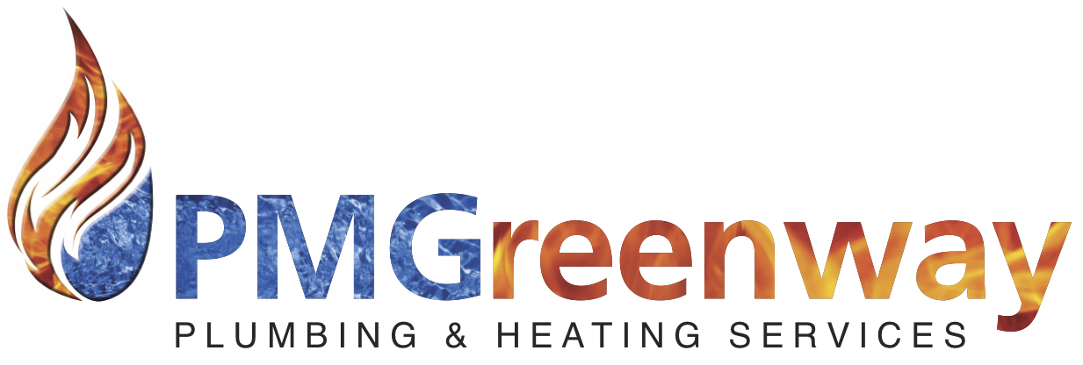

Updated 22/05/2018

PM Greenway Ltd recognises that everyone has a right to equal opportunity and is committed to a policy of equality and diversity. No job applicant or employee, member, volunteer or organisation/individual to which we provide services will be discriminated against by us on the grounds of the following ‘protected characteristics’.
- Gender (including sex, marriage, gender re-assignment)
- Race (including ethnic origin, colour, nationality and national origin)
- Disability (if you suffer a disability as defined by the Disability Discrimination Act, you may wish to inform us, in confidence, so that we can review with you what reasonable adjustments can be made)
- Sexual Orientation
- Religion or belief
- Age
- Pregnancy and Maternity
It is important to understand and recognise the different forms of discrimination in order to encourage equality and diversity.

Direct Discrimination
Direct Discrimination occurs when someone is treated less favourably as a result of that person possessing a protected characteristic.
Discrimination by perception
Discrimination by perception is a form of Direct Discrimination which occurs when someone is treated less favourably because it is thought that he/she associates with another person with a protected characteristic.
Associative Discrimination
Associative Discrimination is a form of direct Discrimination which occurs when someone is treated less favourably because he/she associates with another person with a protected characteristic.
Indirect Discrimination
Indirect Discrimination can occur when you have a rule, practice or procedure within the workplace that applies to everybody; but places a person with a protected characteristic at a disadvantage. Indirect Discrimination does not apply to Pregnancy and Maternity.

Harassment
- Harassment is “unwanted conduct related to a relevant protected characteristic, which has the purpose of effect of violating an individual’s dignity or creating an intimidating, hostile, degrading, humiliating or offensive environment for that individual”. This includes behaviour that an employee may find offensive, even if the behaviour is not directed at that particular employee.
Harassment by a Third Party
Harassment by a Third Party can occur when an employee is harassed at work, even if the harassment is by a person not employed by the employer.
Victimisation
Victimisation occurs if someone is treated badly because they have either made or supported a complaint or grievance under the statutory legislation or this policy.
We aim to promote equal opportunities, eliminate discrimination and eliminate harassment through the following:
- Opposing all forms of unlawful and unfair discrimination.
- All employee’s (whether part-time, full-time or contractors) and beneficiaries will be treated fairly and with respect.
- All vacancies will be advertised, internally and externally simultaneously and will include a statement on equal opportunities.
- Selection for employment/apprenticeships, promotion, training or any other benefit will be on the basis of aptitude and ability. All selection/rejection decisions will be recorded.
- All employee’s/volunteers/members will be helped and encouraged to develop their full potential and the talents and resources of individuals will be fully utilised to maximise the efficiency of the organisation.
All employees have a legal and moral obligation not to discriminate and to report incidents of discrimination against any individual or group of individuals to Hasan Mustafa

Our Commitment:
- To create an environment in which individual differences and the contributions of all our staff and beneficiaries are recognised and valued.
- Every employee, contractor and beneficiary is entitled to be part of an environment that promotes dignity and respect to all. No form of intimidation, bullying or harassment will be tolerated.
- Training, development and progression opportunities are available to all staff.
- Equality is good management practice and makes sound sense.
BREACHES OF OUR EQUALITY POLICY WILL BE REGARDED AS MISCONDUCT AND COULD LEAD TO DISCIPLINARY/LEGAL PROCEEDINGS.
- This policy will be monitored, reviewed and updated annually.
- The policy is fully supported by the management and has been agreed with staff and contractors.
The successful implement of this policy depends on the awareness and commitment of all staff. Hence, all new staff/contractors will be made aware of its existence on joining the company, reminded they must conform with it on a regular basis and asked to sign the Equal Opportunities statement at the end of this policy to confirm they have read and understood its contents.

I acknowledge receipt of:
PM Greenway Limited’s Equal Opportunities Policy Statement

Received by________________________________ Position_______________________
(print)

Signature___________________________________
Date ___________________________________
Please sign and hand back to confirm you have received, read and agree with the Equal Opportunities Policy Statement.

